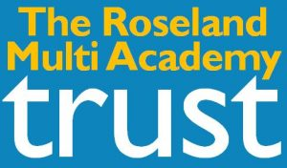

On 1 March 2016 The Roseland Academy, Tregony Primary School and Gerrans Primary School formed The Roseland Multi-Academy Trust (TRMAT).
Due to the unique geographical area of the Roseland peninsula close links have been formed over many years between the primary schools and the secondary school. The formation of TRMAT will enable these close working partnerships to continue and strengthen. Students progressing through from the primary schools to the secondary will experience a seamless transition, through familiarity of staff and premises and, it is hoped over time, through a more integrated curriculum.
There are many benefits from forming TRMAT. Best practice and expertise in specialist areas will be shared between schools, leading to greater standards of education for students. Centralised services will be provided and staffing resources shared, each contributing to more efficient use of funding. As a MAT funding is received directly from central government which allows finances to be focussed where it is needed for each individual school.
TRMAT Development plan for 2016
- Develop strong and effective governance
- Create consistency of standards for teaching, learning and assessment
- Promote benefits of primary into secondary and vice versa
- Develop working relationships between staff in the MAT
- Develop a rigorous and effective school improvement partnership
- Develop a consistent approach to behaviour for learning
- Achieve efficient and effective use of resources
- Create new collaborative student experiences
We have enjoyed a number of shared TRMAT events events since our launch which have benefited the students and staff of our three schools. These have included Y6 Classes at the Roseland during the summer and collaborative events such as World Book Day. In September 2016, staff of TRMAT met and planned a number of exciting developments and opportunities for the coming academic year.
