Gerrans School Remote Learning Plan

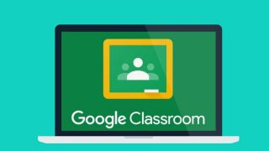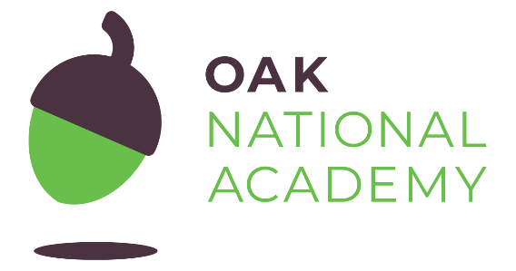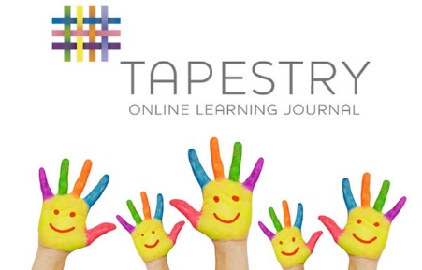
In order to ensure that learning is continued, for any reason the school building is not accessible, irrespective of lockdown and self-isolation, Gerrans Primary School has developed the following plan. This plan offers remote learning opportunities whilst also acknowledging that some households have limited access to devices and would require hard-copies of work and resources.
This plan will be applied in the following instances:
- An individual is self-isolating because of a positive test within the household;
- A group of children are self-isolating because of a case of coronavirus in the bubble;
- A whole bubble or cohort is self-isolating because of an outbreak of coronavirus
- School closure in adverse weather
The plan complies with the expectations and principles outlined in the DFE document Guidance for Full Opening of Schools.
Software and online platforms
Within all plans, teachers will set appropriate work in-line with our current curriculum.
Children will remain in contact with their Classteacher through Google Classroom and Tapestry (For EYFS) (to share successes and communications).
Oak Academy has been selected to support remote learning for a number of reasons. The Oak Academy lessons are in-line with our teaching ethos – they encourage the use of retrieval practice, explicit teaching with high quality modelling, and the use of deliberate practice. The online lessons are free to all and offer a recorded taught session so that the children can access physical teaching from a teacher and then access work relating to that lesson within the same website. There are also hundreds of lessons specifically aimed at children with SEND needs and requiring additional support. Classteachers are to use the lessons in the classroom so children are familiar with the platform.
We will continue to provide TT Rockstars to support the acquisition and retention of times tables. Online reading books will be issued by the class teacher on a weekly basis via Oxford Reading Owl and RWI online resurces .
Google Classroom will remain in use as the communication element has already proved to be invaluable. Teachers and parents will be able to message one another to share information and offer support.

In the event of any form of isolation and loss of learning caused by Coronavirus, parents must understand that engagement in home learning is compulsory, as is the expectation that Gerrans Primary School makes that provision available and accessible to all. However, if children themselves are too ill to attend then they should not be expected to engage in home learning.
In preparation for home-learning, parents and children need to receive logins and passwords for the following platforms (likewise teaching staff need to be familiar with them):
Worksheets and Practical Resources
If you are finding Google Classroom problematic, then please email head@gerrans.cornwall.sch.uk so that we can provide an alternative.
Remote Learning
The initial response to any isolation will be to provide children with home learning materials alongside their class stationery pack (this might need to be delivered). In the case of whole cohort isolation, resources will be uploaded to Google Classroom and priority children will have packs delivered. This measure will afford teachers a short time to prepare their remote learning resources.
Pupil needs to isolate because someone in their household is symptomatic or tests positive
Ongoing Support | Safeguarding/SEND
Using Google Classroom, the class teacher will upload worksheets at 9.00am each morning. The teacher will decide what materials are most appropriate for the individual child.  If teaching input is required for core lessons, the teacher can either provide a Powerpoint, direct the parent to a relevant Oak National taught session. Non-core lessons and resources will also be uploaded.  Feedback will be at the end of the day. | School office to contact parents to ensure a test has been taken and to make sure that parents know to communicate test results to  head@gerrans.cornwall.sch.uk  If child is entitled to benefit-related FSM ensure food made available.  If child is vulnerable in any way, the DSL will ensure that appropriate agencies are notified and arrange for regular wellbeing checks via a phone call from the DSL  If a child does not engage, the Classteacher is to call the parents to discuss obstacles and support.

A group of children are self-isolating because of a case of coronavirus in their class bubble
Ongoing Support | Safeguarding/SEND
Using Google Classroom, the class teacher will upload worksheets at 9.00am each morning.  If teaching input is required for core lessons, the teacher can either provide a Powerpoint, direct the parent to a relevant Oak National taught session. Non-core lessons and resources will also be uploaded.  Feedback will be at the end of the day. | School office to contact parents know to communicate test results to  head@gerrans.cornwall.sch.uk  If children are entitled to benefit-related FSM ensure food made available.  If any child is vulnerable in any way, the DSL will ensure that appropriate agencies are notified and arrange for regular safe and well checks via a phone call from the DSL (record on My Concern ).  Those not engaging with home learning are to receive a phone call from a member of SLT to discuss the obstacles and support.

A whole bubble/cohort of children is isolating because of an outbreak of coronavirus
Ongoing Support | Safeguarding/SEND
Once a week, teachers will provide a google meet for pupils so they have an opportunity to discuss any learning based questions  Teachers will record a story once a week to share with their class. This may be live or pre-recorded.  The headteacher and SENDCO will offer weekly meetings to parents who have a child on The SEN register.  For non-core lessons, resources will be uploaded to Google Classroom and where possible web-links to appropriate support materials will be shared. This will often be through Oak National using lessons that link to Gerrans’ curriculum.  Completed work can be uploaded and parent/pupils can also send photographs of their child’s learning so that success can be celebrated. Teachers/teaching assistants can then review the work complete.  Whole class feedback will address misconceptions etc.  In the event of teachers becoming ill, support staff will be required to ‘takeover’ Google Classroom feedback. | Parents notified so they know to communicate test results to covid@quarry.dudley.sch.uk.  If any children are entitled to benefit-related FSM ensure food made available.  If any child is vulnerable in any way, the DSL will ensure that appropriate agencies are notified and arrange for regular wellbeing checks via a phone call from the DSL (record on CPOMS).  Those not engaging with home learning are to receive an email to discuss the obstacles and the support needed by the family. This could then be followed up by calls from the Headteacher if there are pastoral issues.  Where children would normally receive additional support from SEND agencies, the SENDCO and Headteacher will ensure weekly meetings are offered.  The class teacher will share appropriate Oak National SEND lessons to those who need them.

