Parents Meeting: Fred Talk

What can you do to help at home?

- Speak like Fred throughout the day
- Play Fred games
- Use ‘Fred Talk, read the word’ to read words.

There are free video tutorials on our website – www.ruthmiskin.com

Select ‘More and International’ at the top, then ‘Home reading’ from the drop-down list:

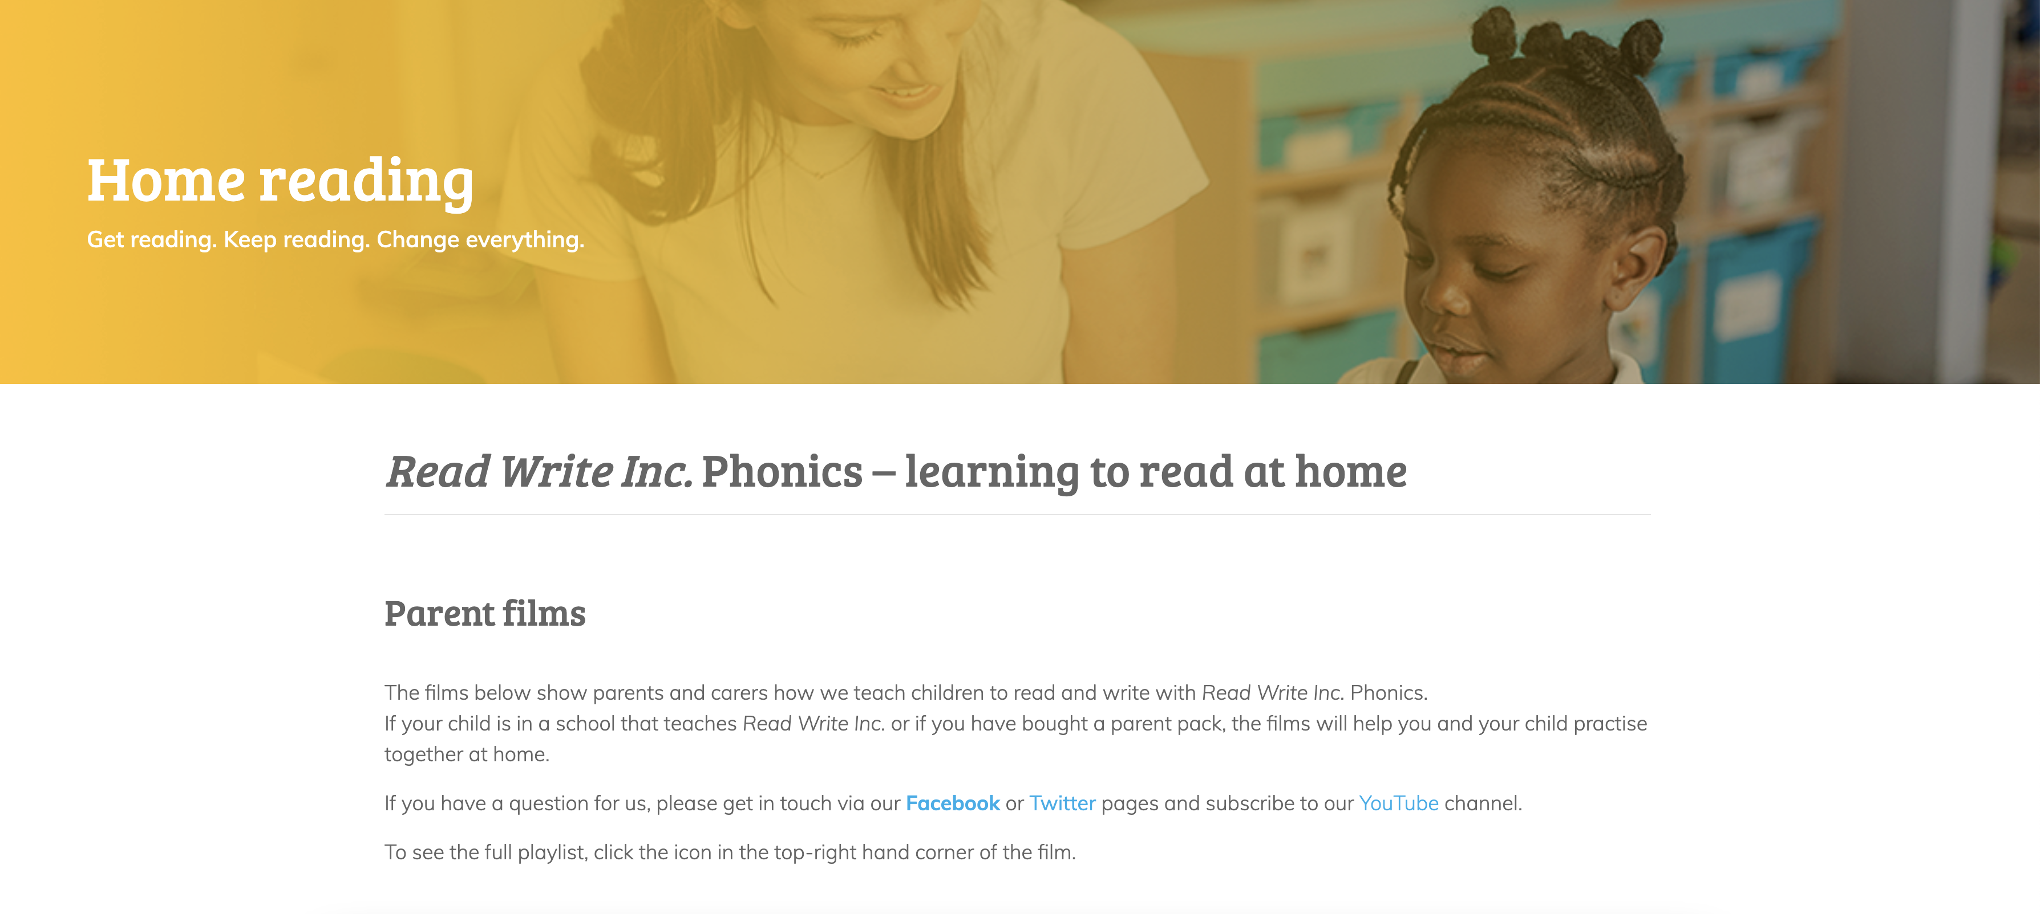

We’re also on Facebook – www.facebook.com/miskin.education

Free e-books for home reading:
http://www.oxfordowl.co.uk/Reading/

