Gerrans School 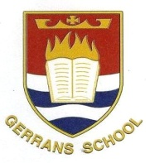

ART AND DESIGN

INTENT:
We want all pupils to primary school finding an area of visual art relevant, engaging and enjoyable. We also want to sharpen their observation skills, have the confidence to form opinions and express themselves through creating. Some knowledge in art such as techniques can be taught, but we also want our pupils to gain experiential knowledge through using different media.
IMPLEMENTATION:
- All lessons are planned using skills progressions so that the curriculum is taught horizontally across the year group, skills are progressed vertically across the key stage, resulting in diagonal learning.

- We have adopted the ‘Access Art’ Curriculum for the following reasons; it gives pupils a wide range of experiences in areas of painting, drawing/sketching, printing, food technology, sculpture, pottery and construction. Children have an opportunity to familiarise themselves with artists from modern day who specialist in that area of art, as well as famous artists from the past. Access Art is also suitable for a non specialist teacher to follow.

- Each lesson encourages the children to discuss, reflect and critique Art and Design work (their own and other’s).

