Gerrans School
Reading

INTENT:
For every child to read words accurately, to comprehend texts and to have a love of reading. Children should be able to discuss, share and explore different texts and have a reading fluency that enables them to access the full curriculum offer and succeed in the future. For all children to develop a love for reading for both pleasure and understanding.
At Gerrans School we want our pupils to:
- Decode words and text confidently
- Have good inference and deduction skills
- Analyse text
- Develop transferable skills
- Be inquisitive about text
- Be passionate and enthusiastic about reading
- Perform texts
- Be fluent and expressive readers
- Verbalise thoughts and ideas
- Enjoy reading
- Develop personal choice or preferences for genres and authors
- Be resourceful by using dictionaries and phonetic knowledge
- Persuade others to read a book
- Critique and provide evidence
- Identify patterns between authors and genres
- Discuss books
- Challenge the opinions of others
- Empathise
- Have an experimental approach to text

IMPLEMENTATION
- Reading Skills are taught to enable children to decode, infer, predict, explain, retrieve, summarise and sequence information.
- Children explore high-quality books in order to develop vocabulary and discuss word meanings.
- Children read a range of fiction and non-fiction books at home and in school.
- Monitoring high expectations of home reading (at least 3 times per week).
Therefore, at Gerrans, we teach reading by;
- Deepening an understanding of texts
- Encouraging discussion about texts
- Analysing and exploring texts through generating and answering questions
- Giving exposure to a variety of genre
- Developing a variety of reading skills which enable pupils to achieve their potential
- Modelling being an interested, excited reader who has a love for reading
- Whole class teaching
- Modelling answers to questions
- Providing opportunity for pupils to read collaboratively and independently
This is because:
- All pupils need a good understanding of what they read
- Pupils need to be inquisitive about texts
- Pupils need to see exemplar answers
- All pupils reading ability needs to be assessed
- Reading is a key skill for life
- All children should be able to share the enjoyment of reading

Gerrans School Library
Our school library has been redesigned by the pupils and funded through community events. Pupils are very proud of the space and use it respectfully. Families are invited to share books together after school.
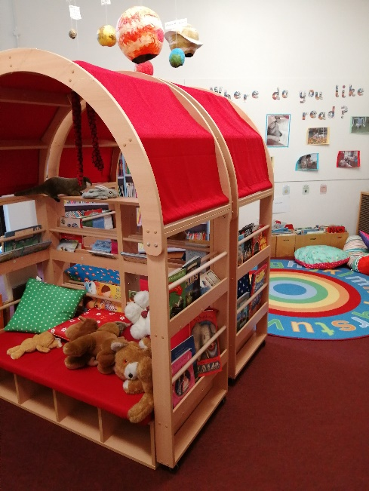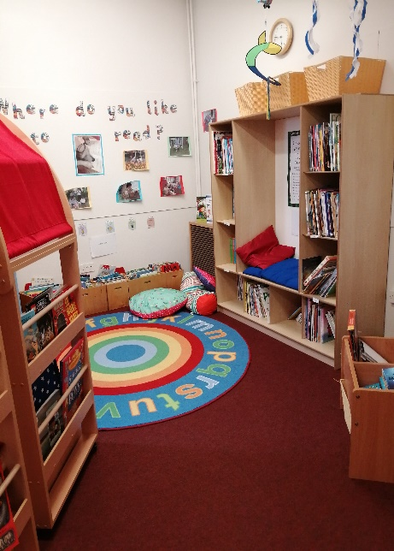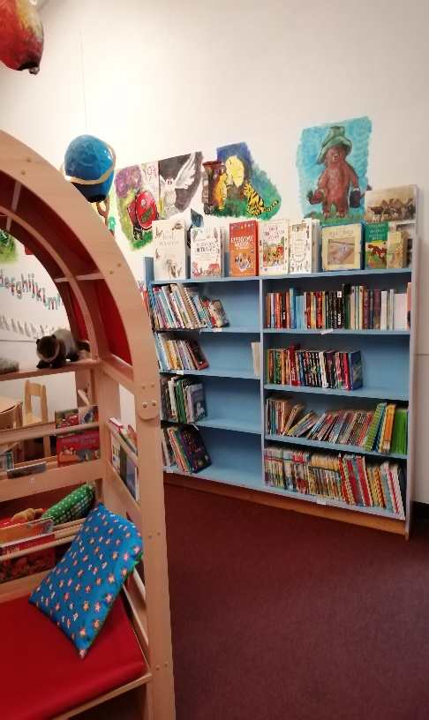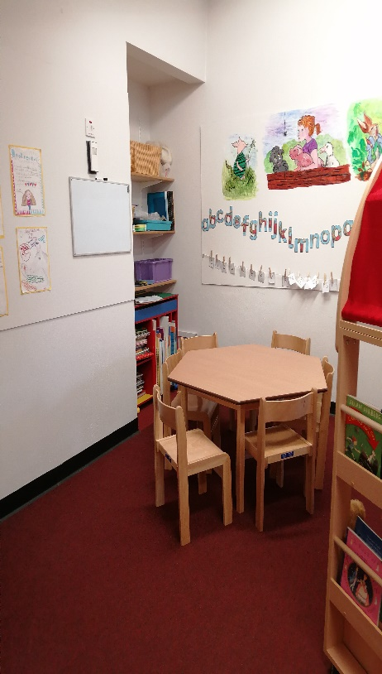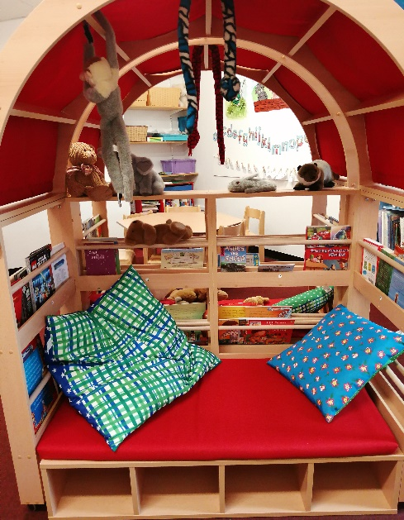
Scamp:
Scamp our school registered PAT dog encourages reading from pupils of all ages and abilities.
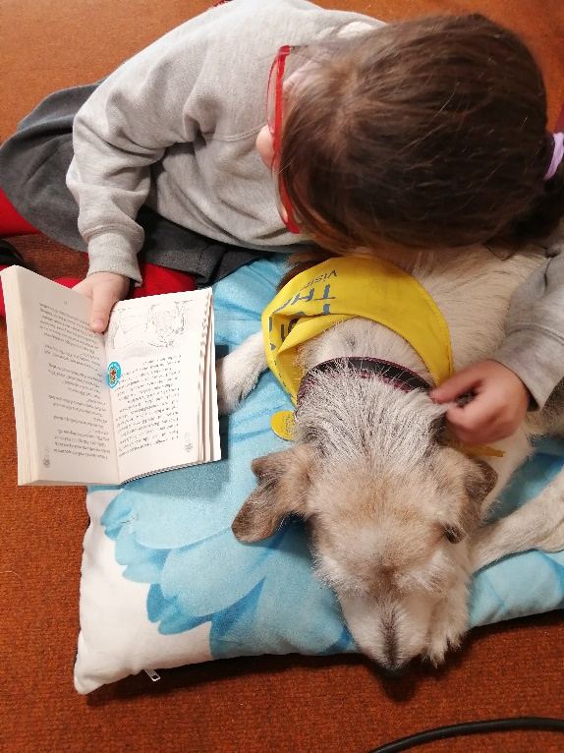

IMPACT:

