Poldark and Levant Maths – Distance Learning Summer Term week 3

Learning Objectives for week –
Poldark ; I am aiming to find change from £5, £10 , £20 by using ‘Frog jumps’ ( counting on)
Levant ; I am aiming to find change using ‘Frog jumps’ ( counting on) when buying several items.

Notes to parents; Subtraction can also be learnt as ‘counting up or counting on’ to the target number, this is the old fashioned shop keeper method of giving change.
Encourage the children to use their number bond to 10 skills. For example if adding on from a 7 the know they add a 3 to make the next ten.
This week’s maths is an ideal opportunity to ‘play shops’. Save food packaging and price up and play shops. Even get the children to set up a role play shop in the garden, they can choose a theme. Handling and looking at real money is also something children today don’t get an opportunity to do, so again this can useful.
Also understanding the value of money. Making realistic price labels for items for sale in role play shop is a valuable exercise. How many items in the kitchen cupboard cost less than a £1? Less than £5? This will give them a realistic value of money. In the input below £5 and £10 notes are used. These can be made up or real. Handling and talking about real money is beneficial as children today don’t have as much opportunity to do it in an on line world.
Please also emphasis that there are 100 pennies to every £1

Learning Input;
- Show children a toy with a price label £4.67. Give a child a £5 note and ask them to use this to pay for the toy.
- You’ve given the shopkeeper too much money. How will she/he calculate how much change to give you? Maths Frog can help us!
- Sketch a line from £4.67 to £5. Where will Maths frog hop to first? The next 10. Mark on £4.70 and draw a hop labelled 3p.
- Where will frog go to next? The next pound! Draw a jump from £4.70 to £5, labelling it 30p:
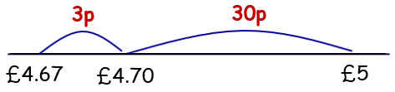
So, how much change should the shopkeeper give?
- Give a £10 note and repeat.
- Show children four items that might be for sale at a seaside shop, e.g. bucket, spade, beach towel and sun cream, with prices £2.74, £1.43, £8.53 and £5.72. (these can be any 4 items, they could be themed to the role play area your child wants to create)
- Imagine you are on holiday and have some money. Which two items could you buy for a total of less than £5? Agree a pair and ask your child to find the total. What would the change be from £5?
Children can be encouraged to use the frog jumping number line to start with then confidently do this orally, talking through their stages.
- First add £2.74 and £1.43 using column addition, then model using Frog to find the change from £5. Remind children: Frog hops to the next 10p, and then to the next £1.
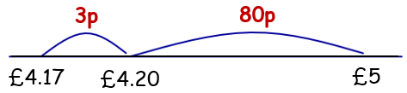
- Which two items could you buy for under £10?
- Children find the total, then use Frog to find the change from £10.
Repeat for a pair of items costing under £20.

Applying Knowledge and Understanding
This can be as creative as possible this week. Once children understand the concept of counting onto the next 10 then the next 100 (£1) have recorded a few times, they can really enjoy role playing as the shop keeper, giving change to their customers and using this method orally. Please play along as the happy customers!
If your child is in Levant, please purchase more than one item, so they have to jot down a column addition first before calculating change.
There is a list of resources attached which could be used if helpful.
Don’t forget to send us any photos please!

