Gerrans School 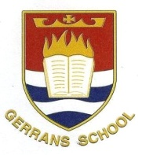
History

INTENT:
Children gain a coherent knowledge and understanding of Britain’s past and that of the wider world.
IMPLEMENTATION:
- All lessons are planned using skills progressions so that knowledge is taught horizontally across the year group, skills are progressed vertically across the key stage, resulting in diagonal learning.
- From Year 3 through to 6, pupils are taught about a wide selection of historical periods from the Stone Age to present day. They use timelines to develop their understanding of the chronological order of these periods and events.
- Children are equipped to ask perceptive questions, think critically, weigh evidence, sift arguments and develop perspective and judgement.
- We encourage children to note connections, contrasts and trends over time and develop the correct use of historical terms.
- Through the use of a whole school timeline, we ensure children have an outstanding knowledge of the context of the different periods of history being taught.
Through teaching history we aim to:
- Fire pupil’s curiosity about the past in Britain and the wider world
- Encourage thinking about how the past influences the present
- Help students develop a chronological framework for their knowledge of significant events and people
- Foster a sense of identity and an increased understanding of pupil’s own position in their own community and the world
- Develop a range of skills and abilities – particularly those related to historical enquiry, inference, interpretation and organisation and communication of historical information.

IMPACT

