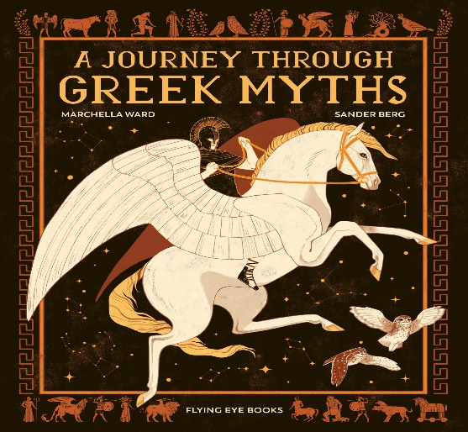
Key Stage Two Autumn Term 2
The Ancient Greeks
The main thread running through this half term is to identify what we have learned from the Greeks and how their culture can influence us with ideas, even today.
In English the class will be studying myths and writing their own.
The pupils will be studying Ancient Greek civilisation and reflecting on how our civilisation is connected through sport, art, philosophy, architecture, and theatre. They will have a chance to explore areas of personal interest and build board games, design and make pots and write their own myths. Children will also be looking at the Aegean Islands and how these compare to the Hebrides and Scilly.

Computing in this Unit is embedded in the form of research. This is a good opportunity to understand how wiki’s and resources like Wikipedia are created and how their contents can be sometimes unreliable. You could create a class wiki of shared research when exploring the Greek gods.

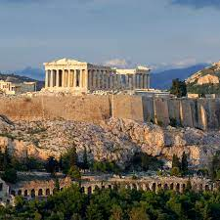

Maths for Year 3 and 4

Multiplication and Division

Doubling and halving
Fractions of amounts
Division
Symmetry
2D and 3D shapes
Maths for Year 5 and 6
Addition and subtraction of money
Multiplication and division
Ordering fractions
Decimal / fraction equivalents
Adding / subtracting fractions
Quadrilaterals
Missing angles
3D shapes
Co-ordinates

English for Year 3 and 4
Guided research about modern Greece and note taking
Reading and comprehension - Myths - Daedalus and Icarus, Demeter and Persephone
Role play
Shared writing own myth
Non-chronological reports – the Gods and ancient Greek heroes
Drama - TV news scripts
English for Year 5 and 6
Independent research about modern Greece, detailed and purposeful note taking, highlighting links to ancient Greece
Reading and comprehension – myths – Daedalus and Icarus, Demeter and Persephone, Theseus and the Minotaur – greater understanding of message behind stories and meanings
Role play
Re-writing the end to an existing myth
Writing own myth incorporating common features
Non-chronological reports – the Gods and ancient Greek heroes
Drama - TV news scripts

Science Y3/4
Science Y5/6
Evolution and Inheritance
Inheritance detectives
Mutations and adaption
Extreme survival
Evolutionary pioneers
Trees and fossils
‘The tale of the giraffe’s neck’
Fit for success
Balanced diets
Food for energy
Skeleton and bones
Moving muscles
Health and fitness

Knowledge learnt in other curriculum areas and beyond
- Presentation of curriculum tasks
- Learning and performing in public Christmas songs/carols
- Remembrance Day in local community
- Christmas Story
- Performing Nativity story as whole school

Key Questions to ask your child at home
- Who were the Ancient Greeks?
- How have the Ancient Greeks influenced our lives today?
- What is meant by ‘Ancient Greece’?
- When were the ‘Ancient Greeks’ in Greece?
- Where is Greece?
- What is Greece like today?

Suggestions for Parental Support at Home
- Learn times tables and division facts y3/4 2 x, 3x, 4x, 5x, 6x, 8x, 10x
Y5/6 2x, 3x, 4x, 5x, 6x, 7x, 8x, 9x, 10x, 11x, 12x
See multiplication support on website and sent home to parents autumn term 2020
Learning spellings
- Counting on and back in whole numbers and decimals
- Secure number bonds to 100
- Reading and research
- Support in planning, preparing and creating curriculum task when set
- Handle money and change as much as possible.

