Maths for Year 3 and 4

Key Stage Two Summer Term 1 2021
Rites and Rituals

This exciting Unit welcomes pupils to the mysterious world of the Mayans.

This highly advanced civilisation flourished in Central America and is noted for its awe-inspiring architectural and astronomical achievements. On a less pleasant note, the Mayans are also remembered for playing highly violent sports and practising human sacrifice to please their bloodthirsty gods!

Pupils design their own mask inspired by Mayan art and learn about their skills in weaving, pottery and sculpture. They also learn about Mayan social customs and structures and the importance of trade and travel, with their excellent road system (despite not knowing about the invention of the wheel!).

The importance of religion and the role of priests in society and the magnificent temples that the Mayans built, is also covered in this Unit, as well as the advances in medicine as practised by the shamans.

Times tables, factors, multiples, division
Partitioning to double, halve and multiply
Mental Strategies
Fractions

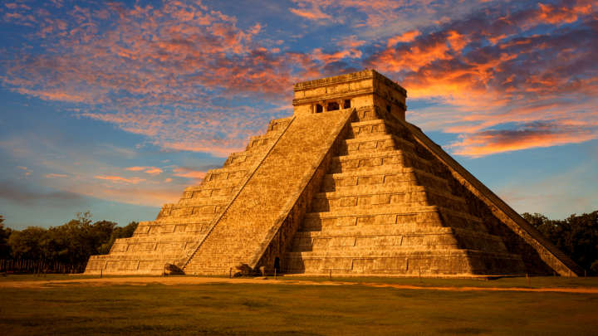
Decimals and money
Decimals and fractions
Area and perimeter
Time
Line graphs and bar charts
Shapes
Co-ordinates and 3D shapes

Maths for Year 5 and 6
Multiplies, factors, mental strategies
Multiplication and division
Units of measure
Time and timetables
Area, perimeter, scaled shapes
Finding volume
Line graphs and pie charts
Algebra
ratio

English for Year 3 and 4
Study advertisements and write advertisements as part of a group

Listen to, and engage with class discussion and debate

Take part in role plays about Mayan life

Read and respond to texts about Mayan life

Write a newspaper report

Use descriptive techniques in writing

Write explanations

Write a letter

Become familiar with spelling patterns

Learn how to use basic punctuation
English for Year 5 and 6
Recognise how advertisements tempt the reader and apply this to writing own advertisement

Take an active role in class discussion and debate

In role play describe and explain aspects of Mayan life

Read and respond to texts about Mayan life

Identify features of report writing and apply in own writing

Write explanations

Apply the conventions of different text types

Write a letter

Spell complex words

Use a range of punctuation appropriately and consistently

Science y3/4
A world of Living Things
Is it living?
A kingdom of plants
Amazing Invertebrates
Fantastic Fish and Astounding Amphibians
Brilliant birds and remarkable reptiles
Magnificent mammals
Science Y5/6
Life Cycles
Flowering Plant reproduction
Insect and Amphibian Life Cycles
Mammalian and Bird Life Cycles
Foetus to child
Adolescence and puberty
A Healthy Human Body

History
The study of a non-European society which provides contrasts with British history- Mayan Civilization AD900.
Knowledge learnt in other curriculum areas and beyond
- Preparation for Sports’ Day
- Familiarisation with A Midsummer Night’s Dream and William Shakespeare
- Caring for hens and Guinea pigs
- Carrying out an archaeological dig

Suggestions for Parental Support at Home
- Learn times tables and division facts y3/4 2 x, 3x, 4x, 5x, 6x, 8x, 10x
Y5/6 2x, 3x, 4x, 5x, 6x, 7x, 8x, 9x, 10x, 11x, 12x
See multiplication support on website and sent home to parents autumn term.
- Support y5/6 in understanding about body changes associated with puberty
- Opportunities in local area of discussing life cycles in plants and animals

Key Questions to ask your child at home
Ask ‘what if’ questions.
What would it have been like to live in Ancient Mayan Society?
Why did the Ancient Mayans build pyramids?
Where did the Ancient Mayans life?
How do animal life cycles differ to other living things?
Why do some plants have bright, colourful flowers?

