KS2 Science Learning for week beginning 11th May
Learning Objectives:
I am learning to construct and interpret a variety of food chains, identifying producers, predators and consumers
Extension for Year 5 and Year 6:
Research into food chains from specific habitats. For Example: Dessert, rainforest, tundra, Arctic, woodland, beach etc.
Relate to photosynthesis
Understand energy transfer and loss in food chain pyramids

Notes to Parents: Children need to understand that all food chains contain ‘producers’ ‘consumers’ and ‘predators’. Some food chains increase in complexity and may contain primary, secondary and even tertiary consumers.
Producers – these are generally green vegetation which gain energy directly from the sun. For example, grass
Consumer- Eat the producer therefore gaining energy from it. For example, rabbit.
Predator – eat the prey therefore gaining energy from it. For example, fox.
Energy transfers from one tier of the food chain to another. Food is energy.
Energy transfer is shown by an arrow.

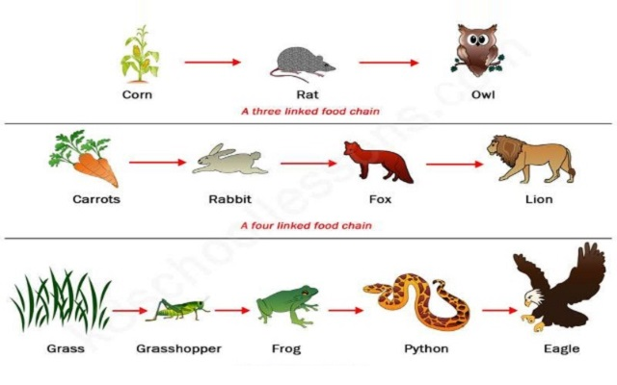

Children also need to learn that for any food chain to support a predator, there will be a lot of consumers and even more producers below. This can also be represented as a food pyramid, showing that the amount of energy consumed in each level decreases up the pyramid. Energy will be lost at each level as well.

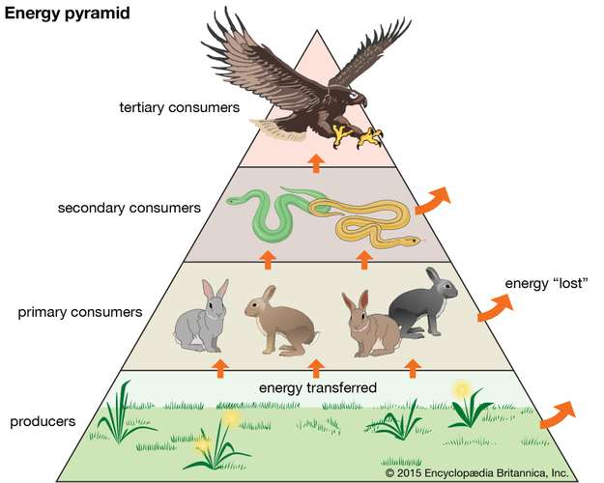

Learning Activities

- Ask the children to describe a food chain they know and describe it to you.
- Help them understand that; the producer gains it’s energy from the sun ( Y5/6 should be able to tell you about photosynthesis), energy is transferred up the food chain as well as being lost on the way.
- Ask the children to choose a habitat they are familiar with; garden or beach for example and draw and label a food chain.
- Discuss the key vocabulary used in labelling; producer, consumer, predator. Also discuss the direction to draw the arrow in, arrow means energy is transferred to.
- Y5/6 research in to at least one other habitat and draw and label food chain. Can they find one with more than one consumer?

Challenge;

In the food chain

Carrot Rabbit Fox

What would happen to the fox if all the rabbits died?

