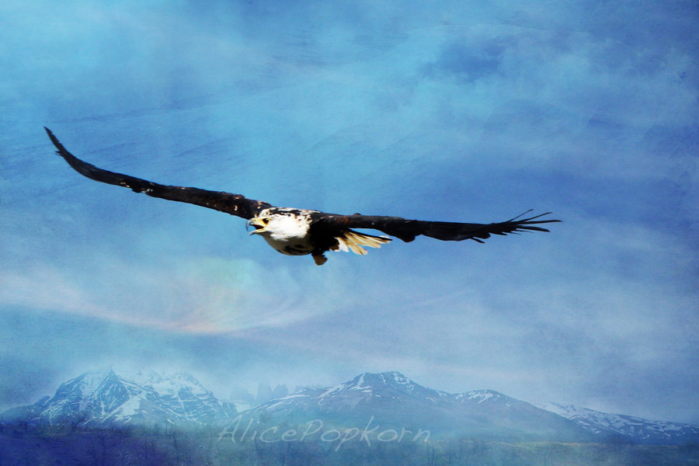

English

Stories – Room on a Broom

Recipes for a flying spell

Recounts

Poetry –‘Twas the night before Christmas

Letters to Santa

Invitations

A Christmas wish

Christmas around the world

Maths

Shape and space

Multiplication and division

Money

Time

Investigation and reasoning

RE/PSHE

Aspirations/ reaching high

Special talents

Jesus’s miracles

Christmas

Science

Explore materials – names and qualities

Which materials would be suitable for making an aeroplane/flying machine?

Investigate materials

How have materials/uses changed?

Key Vocabulary

Flight, aeroplane, travel, airport, slider, wings, pivot, inventions, aerial, thermals, aviation.

Parent Support/key questions

Spellings, reading practise, Show and Tell

Discuss and research flight

Make and investigate flying machines, paper aeroplanes

How flight has changed peoples’ lives?

Where would you fly to?

Aerial photography

**EYFS** learning takes place within the context of the Development Matters/Birth to 5 curriculum.

Flying High

*‘Aspiration’’*

History

The history of flight

The story of the wright brothers

What qualities do you need to be an inventor?

How has the invention of flight changed our lives?

Music

Christmas songs

Composition/flight music

Appraisal of well-known music - carols

Geography

Aerial photos of local landmarks

Creating maps from these photos

Directions for Santa

Computing

Creating a word document and saving it.

Technology in our lives/jobs

Art and Design

Chimeric flying creatures

Xmas decorations

Slider mechanisms

Christmas cards

Knowledge learnt in other curricular areas and beyond

Outdoor learning

Character profiles

Puppet/drama

Alternative versions

Paired reading

Peer tutorage

Big write