Gerrans School Remote Learning Plan

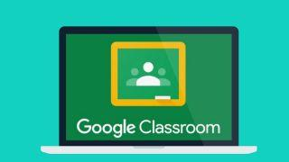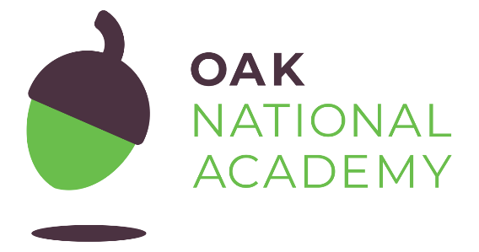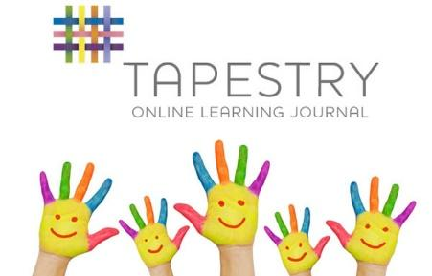
In order to ensure that learning is continued, irrespective of lockdown and self-isolation, Gerrans Primary School has developed the following plan. This plan offers remote learning opportunities . Parents are asked to make the class teacher aware if they have limited or no access to devices, so this can be resolved in advance.
This plan will be applied in the following instances:
- An individual is self-isolating because of a positive test within the household;
- A group of children are self-isolating because of a case of coronavirus in the bubble;
- A whole bubble or cohort is self-isolating because of an outbreak of coronavirus
The plan complies with the expectations and principles outlined in the DFE document Guidance for Full Opening of Schools.
Software and online platforms
Within all plans, teachers will set appropriate work in-line with our current curriculum.
Children will remain in contact with their Class teacher through Google Classroom and Tapestry (For EYFS) to share successes and communications.
Google Classroom will remain in use as the communication element has already proved to be invaluable. Teachers, pupils and parents will be able to message one another to share information and offer support. The School Facebook and website will offer the chance for teachers to celebrate children’s work and maintain our school community.

In the event of any form of isolation and loss of learning caused by Coronavirus, parents must understand that engagement in home learning is compulsory, as is the expectation that Gerrans Primary School makes that provision available and accessible to all. However, if children themselves are too ill to attend school then they should not be expected to engage in home learning.
In preparation for home-learning, parents and children need to receive logins and passwords for the above platforms. Each child has already been issued with theses. Please contact class teachers if you are having trouble logging into to this year’s Google Classroom. Parents of children in Reception will need to log into KS1/EYFS. Parents of children in Year 3 should log into KS2. Other year groups are already established in the correct classes.
Parents who need to log in have already been sent invites from the class teachers.
Worksheets and Practical Resources
If you are finding Google Classroom problematic, then please email class teachers so that we can help. Learning resources will always be uploaded to school website Autumn Term Distance Learning 2020 tab.
Psteward@gerrans.cornwall.sch.uk
ehaines@gerrans.cornwall.sch.uk
head@gerrans.cornwall.sch.uk
Remote Learning
The initial response to any isolation will be to provide children with home learning materials. In the case of whole cohort isolation, resources will be uploaded to Google Classroom and will follow the termly curriculum plans.
Pupil needs to isolate because someone in their household is symptomatic or tests positive
Ongoing Support | Safeguarding/SEND
Using Google Classroom, the class teacher will upload learning materials appropriate for the individual child/ children along with guidance notes for parents.  Feedback will be weekly via the parent/pupil feedback sheet.  Parents of pupils in the EYFS can send photographs and comment on what their child has been learning about. These can be uploaded as part of their Learning Journals. Parents can send photographs of their child’s learning to class teachers.  Parents of Nursery pupils will be emailed suggested activities relevant to the child’s stage of development. | School office to contact parents to ensure a test has been taken and to make sure that parents know to communicate test results to head@gerrans.cornwall.sch.uk or secretary@gerrans.conrwall.sch.uk  If a child is entitled to benefit-related FSM, ensure food is made available from the earliest opportunity.  If child is vulnerable in any way, the DSL will ensure that appropriate agencies are notified and arrange for regular wellbeing checks via a phone call from the DSL  If a child does not engage with home learning, the Class teacher will contact the parents to discuss obstacles and offer support.  If a class teacher has any concerns regarding any pupil, these must be referred to the SGL.

A group of children are self-isolating because of a case of coronavirus in their class bubble
Ongoing Support | Safeguarding/SEND
Using Google Classroom, the class teacher will provide materials and activities for learning to continue at home. These will also be available via the school website.  If teaching input is required for core lessons, the teacher will provide support notes for parents.  Feedback will be weekly via the parent/pupil feedback sheets.  Parents of pupils in the EYFS can send photographs and comment on what their child has been learning about. These can be uploaded as part of their Learning Journals. Parents can send photographs of their child’s learning to class teachers.  Parents of Nursery pupils will be emailed suggested activities relevant to the child’s stage of development. | School office to contact parents to ensure they know to communicate test results to head@gerrans.cornwall.sch.uk or  secretary @gerrans .conrwall.sch.uk  If children are entitled to benefit-related FSM ensure food made available as soon as possible.  If any child is vulnerable in any way, the DSL will ensure that appropriate agencies are notified and arrange for regular wellbeing checks via a phone call from the DSL  Those not engaging with home learning are to receive a phone call from the class teacher to discuss the obstacles and offer support.

A whole bubble/cohort of children is isolating because of an outbreak of coronavirus
Ongoing Support | Safeguarding/SEND
Completed work can be uploaded and parent/pupils can also send photographs of their child’s learning so that success can be celebrated. Teachers/teaching assistants can then review the work complete.  The head teacher and SENDCO will offer weekly meetings to parents who have a child on The SEN register.  Whole class and individual feedback will be shared two ways between home and school.  In the event of teachers becoming ill, parents will be signposted to learning set online by Oak National Academy.  Parents of pupils in the EYFS can send photographs and comment on what their child has been learning about. These can be uploaded as part of their Learning Journals  Parents of Nursery pupils will be emailed suggested activities relevant to the child’s stage of development.  Reminders and guidance will be given about engaging in stories. | Parents notified so they know to communicate test results to head@gerrans.cornwall.sch.uk or  secretary@gerrans.conrwall.sch.uk  If any children are entitled to benefit-related FSM ensure food made available.  If any child is vulnerable in any way, the DSL will ensure that appropriate agencies are notified and arrange for regular wellbeing checks via a phone call from the DSL.  Those not engaging with home learning are to receive an email to discuss the obstacles and the support needed by the family. This could then be followed up by calls from the Head teacher if there are pastoral issues.  Where children would normally receive additional support from SEND agencies, the SENDCO and Head teacher will ensure weekly meetings are offered.

