Key Stage Two Autumn Term (2) 2020
No Way Back!
This unit is a science based unit based around materials and their properties based around change, including the changes which happen during the process of cooking.

Maths for Year 3 and 4
- Strategies for division
- Strategies for addition and subtraction
- Doubling and halving
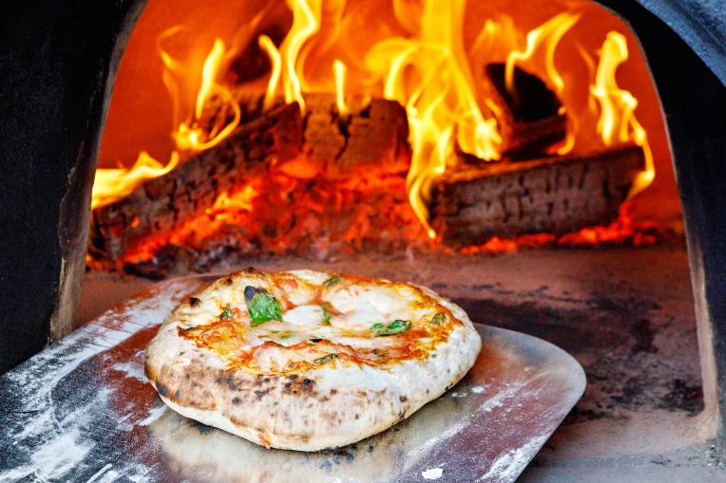
- Understanding fractions
- Finding fractions of amounts
- Symmetry and shape

Maths for Year 5 and 6
- Multiplication and division problem solving
- Addition and subtraction including money , decimals and word problems
- Ordering fractions
- Adding and subtracting fractions
- Properties of 2D and 3D shapes

English for Year 3 and 4
- Information gathering
- Questioning skills
- Discussion/speaking skills
- Writing from a viewpoint
- Information texts
- Ongoing spelling, punctuation and grammar strategies
- Ongoing reading and comprehension

English for Year 5 and 6

- Identifying and gathering information
- Phrasing questions
- Debating
- Persuasive writing techniques
- Information texts
- Ongoing spelling, punctuation and grammar strategies
- Ongoing reading and comprehension

Key Vocabulary
Solid, liquid, state, matter, particle, grain, category, classify, group, evidence, question, discuss
Solidifying, freezing, melting, condensing, evaporating, particles, thermometer, temperature, Celsius, Fahrenheit, degrees
Gas, state, particles, evidence, proof, explain Packaging, recycling, environment, glass, plastic, paper , yeast, dough, kneed, rise, leven, unleavened, carbon dioxide, irreversible change

Electricity, electrical circuit, complete circuit, circuit symbol, components, cell, battery, positive/negative, connect/connection, loose connection,
wire, crocodile clip, bulb, bright/dim, switch, buzzer, volume, motor, fast(er)/slow(er), voltage, current, conductor, insulator, metal/non metal, enquiry question, investigation, findings

- Recipe writing

Science
- Properties of liquids, solids and gases
- Changing state
- Exploring evaporation and condensation
- The water cycle

In addition, Year 5 and 6
- Understanding electricity and circuits
- Function of electrical components
- Investigating, designing and constructing circuits

Design and Technology
- Design a make a healthy pizza including base
- Origins of food
- effect of yeast
- analyse effect of heat on different toppings
Knowledge learnt in other curriculum areas and beyond
- Real life budgeting of ingredients to make pizzas
- Learning and performing the Christmas story and songs
- Christmas fundraising – Santa stroll
- Sharing of presentation of Curriculum tasks
- History and source of foods

Suggestions for Parental Support at Home
- Learning Times tables
- Rehearsing time tables for really quick recall
- Using times tables facts to calculate division facts
4x5=20 5x4=20
20÷4=5 20÷5=4
- Handling money in a real life shopping context
- Strong number bonds to 100
- Reading, rehearsing spellings
- Open and closed questions
- Speaking clearly for a purpose in front of others
Observe how liquids and solids at home behave. Exploratory play with rice, sponges, water, ice
- Squashing plastic bottles with lids on or inflated balloons. What’s inside?
- Discuss electricity use in the home
- Discuss electrical safety
- Making potato or lemon clocks
- observing in local environment on the news alternative ‘greener’ ways to generate electricity.
- Encourage research into how electric cars work?
- Support with reading food labels
- Make bread or pizza
- Let children help put shopping away and look at packaging
- How does the traffic light system on food packaging help with healthy eating?
- Is all bread the same? If not, why not?
- How could certain packaging be more environmentally friendly?
- How do the toppings change when they cook?

Key Questions to ask your child at home
Ask ‘what if’ questions.
What happens to the brightness of a bulb if I increase or decrease the number of bulbs in a circuit?
What happens to the brightness of a bulb if I increase or decrease the length of the wires in the circuit?
What happens to the brightness of a bulb if I increase or decrease the thickness of the wires in the circuit?
Is rice a liquid or solid? Explain
How do you know gasses exist if you can’t see them?
What happens to the water in a puddle? Does it disappear?

