Key Stage Two Spring Term 1 2021

Fire, Fever, Fashion.

This topic is designed to take pupils on an exciting journey back in time to 17th century London in the era of the Plague and the Great Fire.

This is the London of Charles II, Sir Christopher Wren and the diarists Samuel Pepys and John Evelyn.

Pupils will enjoy learning about the ‘cures’ for the plague sold by so-called quack doctors. They will wish that they could have visited a frost fair on the frozen River Thames. They will be fascinated by the curious fashions and fads of the time, including little boys in frilly pink skirts!

The topic aims to immerse pupils in a time and place that might feel strangely familiar to them in some ways (chatting in coffee shops) but utterly bizarre in others (men wearing elaborate peaked wigs as a fashion statement).

**Maths for Year 3 and 4**

* 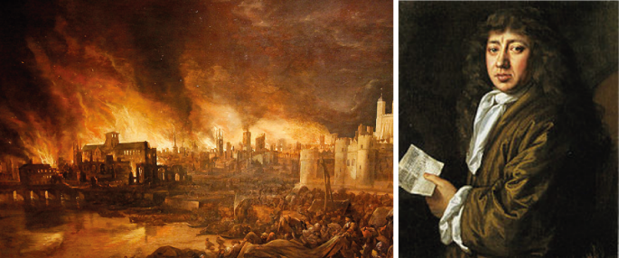Negative numbers



* X and ÷ money
* Decimals in context of money
* Equivalent fractions
* + and – fractions
* Addition and subtraction methods

**Maths for Year 5 and 6**

* Place Value
* Negative Numbers
* Use of brackets in calculations
* Addition and subtraction
* Decimals
* X ÷ - + fractions

**English for Year 3 and 4**

* Recognise different text types
* Show awareness of different viewpoints
* Contribute to class discussions
* Use persuasive vocabulary
* Take part in role plays
* Write factual reports
* Tell stories through art
* Write descriptions
* Write diary accounts

**English for Year 5 and 6**

* Contrast and compare different texts
* Show awareness of different viewpoints
* Write from different viewpoints
* Contribute to and class discussions
* Recognise and use persuasive speaking and writing techniques
* Explore differing characters including through role play
* Write factual reports recognising the features of this text type
* Tell stories through art
* Use descriptive writing techniques
* Write diary accounts recognising the features of this text type

Science Science

Y3/4 – Listen Up! Y5/6 – May the forces be with you

* What is sound? Gravity
* How do we hear sounds? Balanced and unbalanced forces
* Exploring vibrations Air resistance
* Pitch and Volume Levers and gears

Friction

History

* Health and Hygiene of London in 17th Century
* The Great Fire of London
* Samuel Pepys
* Sir Christopher Wren
* St Pauls Cathedral
* The Plague

**Knowledge learnt in other curriculum areas and beyond**

* Curriculum tasks preparation and presentation
* Virtual comparison of Gerrans to London

**Suggestions for Parental Support at Home**

* Learning Times tables
* Rehearsing time tables for really quick recall
* Using times tables facts to calculate division facts

4x5=20 5x4=20

20÷4=5 20÷5=4

* Handling money in a real life shopping context
* Strong number bonds to 100
* Reading, rehearsing spellings
* Open and closed questions
* Speaking clearly for a purpose in front of others
* Understanding of past, present and future
* Understanding of history time line and chronology
* Understanding in what ways peoples’ lives in the past were different.

**Key Questions to ask your child at home**

Ask ‘what if’ questions.

How is sound made?

What is gravity?

Why are people in Australia not standing on their heads?

What is the link between gravity and tide?

How are different animals designed to hear?

Why do we see lightening before we hear thunder?

Where is London? – locate on Google Earth/ Maps/ Atlas

How is London different/similar to Gerrans?