Gerrans School 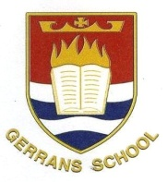
MUSIC
INTENT;
At Gerrans, it is our intent to make music an enjoyable, creative and stimulating learning experience for all pupils. We are committed to ensuring everyone understands the value and importance of music in the wider community.
IMPLEMENTATION:
- All lessons are planned using skills progressions so that knowledge is taught horizontally across the year group, skills are progressed vertically across the key stage, resulting in diagonal learning.
- Lessons offer a range of musical genres, with a wealth of opportunities to develop skills in performing, composing, listening and evaluating music.
- Children are taught to sing and play musically with increasing confidence and control.
- The musical elements of rhythm, melody, harmony, form, dynamics, tempo and timbre are embedded in classroom activities, ensuring skills are developed and built upon from previous year groups.
- All pupils have the opportunity to sing collaboratively in public during our annual Christmas and Summer whole school productions.
IMPACT

