[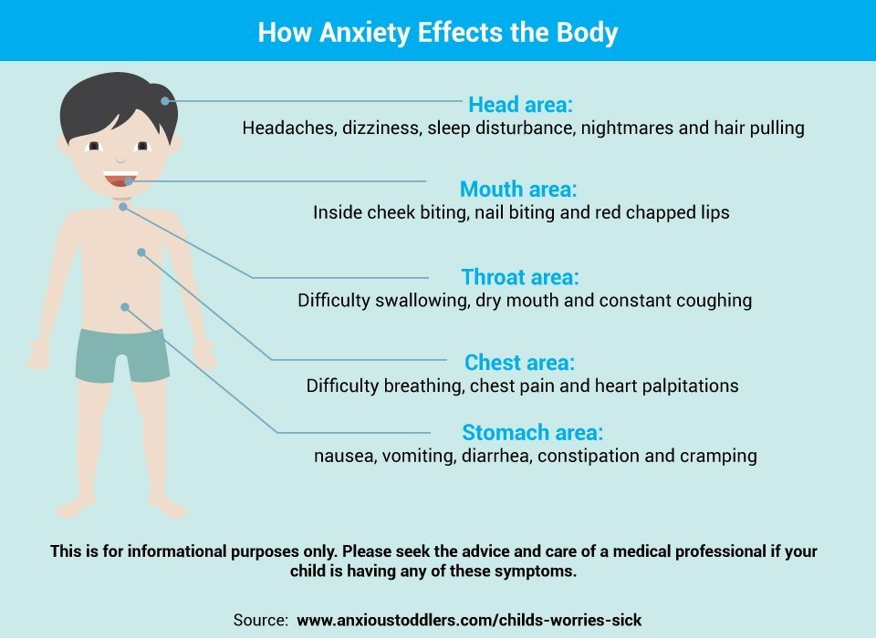](https://www.google.com/url?sa=i&rct=j&q=&esrc=s&source=images&cd=&cad=rja&uact=8&ved=2ahUKEwiAnu6x8ZrgAhViA2MBHVaaAsAQjRx6BAgBEAU&url=https://www.anxioustoddlers.com/missed-child-anxiety/&psig=AOvVaw1bSLRWnh2z_hawmaTpzvFF&ust=1549122503584463)