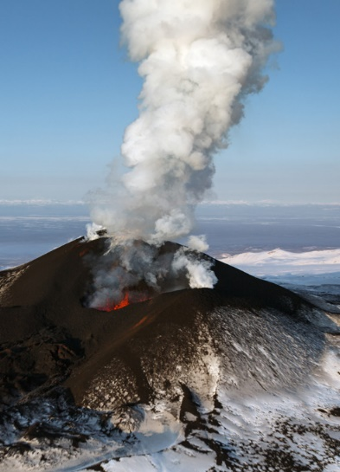
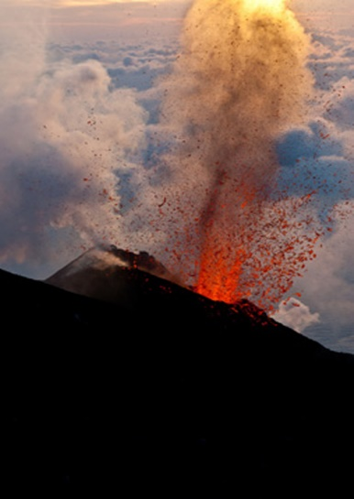
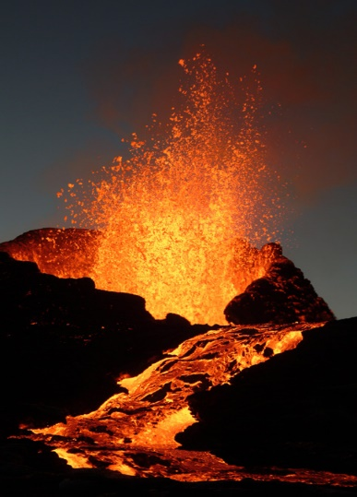
Key Stage Two Autumn Term 1
Angry Earth

This is a geography based Unit of work, and the launch lesson will focus on the Earth’s crust and the creation of volcanoes and earthquakes; types of volcanoes; and the dramatic and explosive physical effects of volcanic eruptions.

Pupils will then study the distribution of volcanoes and earthquake zones around the world . They will also explore the human impact of volcanic activity and the reasons why people choose to live near volcanoes. The main focus for this Unit will be the eruption of Vesuvius. One of the most catastrophic and famous eruptions in European history, the Vesuvius eruption in 79 AD will provide the stimulus for many of the lessons in this Unit.

Pupils will apply their knowledge of previous studies of Roman Britain and explore the evidence that remains, after the dramatic and devastating eruption of Vesuvius, to understand more about life in the city of Pompeii. They will also examine the letters of Pliny the Younger as preparation for writing their own eyewitness accounts of the events leading up to and following the eruption of Vesuvius.

In their English work, pupils will use the eruption of Vesuvius as the focus for a dramatic performance. They will plan and write a script for a short play portraying family life and events in Pompeii just before the volcano erupted and ending with their attempted flight from the lava flows. For the performance, they could also use a recording of sound effects and a composition they have prepared in music.

Volcanoes will also be the focus for poetry work. Pupils will study poems on volcanoes and explore personification, in preparation for composing their own poems on volcanoes and the AD 79 eruption of Vesuvius. They will also be using information from their work in geography to prepare for a role-play, where pupils will act in role as members of families who are making a decision about settling in an area near to a live volcano.

In their art and design work, pupils will be looking at famous paintings of volcanoes and the physical structure of volcanoes, before trying out the sgraffito technique. Music will provide an opportunity to listen to and evaluate pieces that create a dramatic effect and pupils will then prepare suitable sound effects and compose music for their dramatic performance at the end of the Unit.
In computing the pupils will identify currently erupting volcanoes using the internet and research data on volcanic eruptions in the past and the threat of likely future eruptions. Finally they will create a poster that effectively warns people about the volcano in their vicinity

Maths for Year 4

Ordering and Comparing Numbers
Roman Numerals to 100
Place Value in 3 and 4 digit numbers
Addition and subtraction 1, 10, 100, 1000
Strategies for addition and subtraction
Number bonds to 100
Rehearsing and understanding multiplication tables
Doubling and halving
Fractions
Finding fractions of amounts
Division

Maths for Year 5 and 6
Place Value in 5 and 6 digit numbers
Roman Numerals to 1000
Column addition of whole numbers and decimals
Column subtraction
Place Value in 2 and 3 decimal numbers
Counting forward and back in 0.1, 0.01, 0.001
Adding and rounding decimals
Properties of numbers including prime numbers
Written multiplication methods
Mental subtraction methods
Money and change
Problem solving
Written division strategies

English for Year 4
Punctuation – focus on using commas, speech marks and ending sentences appropriately
Spelling – suffixes – tion &sion, ment, ness, ship, ance & ence, dom
Verbal description
Written description
Phrasing sentences to describe opinion
Explanatory writing
Poetic writing
Playscript
Drama/performance
English for Year 5 and 6
Punctuation - using commas and speech punctuation accurately within their own writing. Ending their sentences appropriately.
Spelling – suffixes – tion, sion, ment, ness, ship, ance & ence, dom
Descriptive writing with appropriate structure and vocabulary
Verbal and written debating skills
Complete explanation text
Descriptive poetry
Writing and performing playscripts

Science Vocabualry
Life Processes, movement, reproduction, sensitivity, nutrition, excretion, respiration, growth, living things, oxygen, energy, senses, environmental, classification, mosses, ferns, spores, vertebrates, invertebrates, molluscs, echinoderms, arthropods, crustaceans, arachnids, reptiles, mammals, warm blooded, cold blooded, phylum, species, genus, characteristics

Geography –
Location of countries, using globes, maps, atlases.
Location of plate tectonics , Ring of Fire.
Formation and causes of volcanoes and earthquakes
Science –Living Things and Their habitats
Learning about Living Things and the Life Processes they all share. Learning how living things are classified.
Characteristics of groups
Progression through investigation skills.

Knowledge learnt in other curriculum areas and beyond
- Paddling skills and confidence
- Swimming
- Rugby skills
- Preparation for Harvest festival
- Art and poetry for Gerrans Show
- Incubating and hatching eggs
Geography Vocabulary
Core, mantle, crust, magna, lava, tectonic plates, chamber, extinct , dormant, active, magnitude, Richter Scale, seismic activity

Suggestions for Parental Support at Home
- Learn times tables and division facts y3/4 2 x, 3x, 4x, 5x, 6x, 8x, 10x
Y5/6 2x, 3x, 4x, 5x, 6x, 7x, 8x, 9x, 10x, 11x, 12x
See multiplication support on website and sent home to parents autumn term 2020
Learning spellings
- Be aware of any seismic activity happening globally in news
- Opportunitites to place countries on a map
- Counting on and back in whole numbers and decimals
- Secure number bonds to 100
- Reading and research

Key Questions to ask your child at home
- What causes Earthquakes?
- What causes Volcanoes?
- Where do they occur?
- Why do people still live near volcanoes?
- Are there any benefits to volcanoes and earthquakes?

