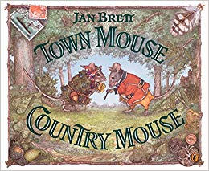

Parent Support/key questions

Spellings, daily reading practise, Show and Tell

I wonder…? Eg How does (town) compare to (village)?

Maths

Direction, position and movement

Fractions

Measures: length, shape

Multiplication, division

99 club

Mental maths

Reasoning

Key Vocabulary

Town, countryside, habitat, environment, mark-making, pattern, texture, shape, living things, survival, micro habitat, minibeast,

Town Mouse & Country Mouse

*‘Responsibility’*

Knowledge learnt in other curricular areas and beyond

Outdoor learning

Character profiles

Puppet/drama

Alternative versions

Paired reading

Peer tutorage

Big write

**EYFS** learning takes place within the context of the Birth to 5 Matters curriculum.

Geography

Compare rural and city life

Contrast with a school in another location in UK.

Pinpoint where we are and where link school is on maps

Small world layouts to compare and contrast physical and human features.

Science

**Living Things and their Habitats**

Comparing living and non-living things, and things that have never lived

Investigate a range of habitats

Explore a microhabitat

Simple food chains

Music

Describe musical elements such as tempo, dynamics, duration

Habitat sounds

Compose music for diff places, friends

Listen and appraise diff musical genres

Music/feelings from photos of places

Computing

Directional language – programme Beebots…visit different habitats

Sequences of instructions, patterns and simple programming

RE/PSHE/SRE

Friendship

Responsibility

Easter

Art and Design

Design and make a vehicle to transport Town Mouse and Country Mouse

Visit to local garage

Design 3 habitats

Photographic images of ‘miniscule’ microhabitats

English

Town Mouse Country Mouse stories

Letters and messages between the mice, to children from a contrasting school

Info pamphlet about our school /village

Research linked to Science: posters about habitats.